**Experiment No.: 4**

**Name: Akhila Anand**

**Roll No:3**

**Batch:Rmca-B**

**Date:12-09-2022**

**Aim**

Perform Z-score normalization, Min-max normalization using iris dataset

from sklearn.datasets import load_iris

from sklearn.preprocessing import MinMaxScaler

import numpy as np

X, y = load_iris(return_X_y=True)

print(X.shape)

scaler = MinMaxScaler()

scaler.fit(X)

X_scaled = scaler.transform(X)

X_scaled

**Output**

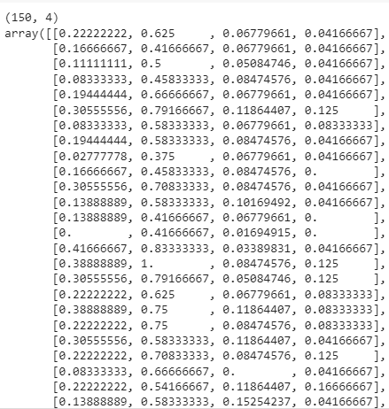

import matplotlib.pyplot as plt

fig, axes = plt.subplots(1,2)

axes[0].scatter(X[:,0], X[:,1], c=y)

axes[0].set_title("Original data")

axes[1].scatter(X_scaled[:,0], X_scaled[:,1], c=y)

axes[1].set_title("MinMax scaled data")

plt.show()

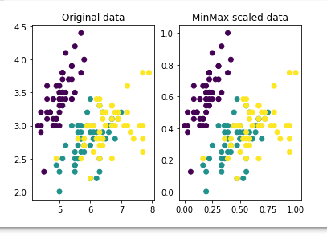

from sklearn.model_selection import train_test_split

X_train, X_test, y_train, y_test = train_test_split(

    X, y, test_size=0.2, random_state=42, stratify = y)

from sklearn.neighbors import KNeighborsClassifier

model=KNeighborsClassifier(n_neighbors=5,metric='minkowski')

model.fit(X_train, y_train)

y_pred=model.predict(X_test)

model.score(X_test, y_test)

